**Project 2-How to create new instance using Amazon Machine**

**Creating image**

**Steps**

**1.** Under the EC2 dashboard, select instances

**2.** Check the deek-server. Under **Actions** drop down button select Images and templets and then select create image.

**3.** Provide the image name and description as deek-backup.

**4.** Click the create image button.

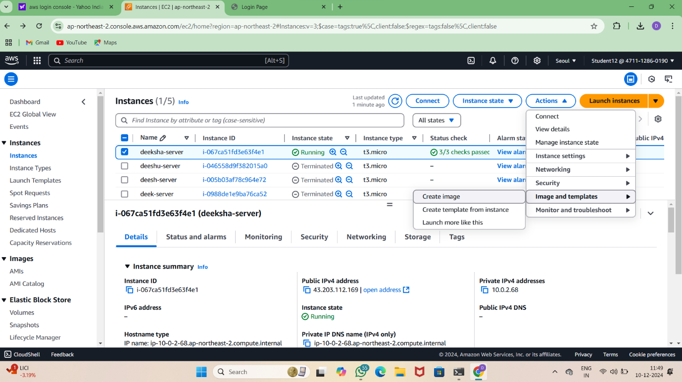

**Create Instance**

**Steps**

**1.** In the EC2 dashboard, select AMI under **Images**

**2.** Check the deek-backup*,* click the Launch instance from AMI.

**3.** Provide the name as deek-backup-server.

**4.** Provide the instance type as t2.micro and provide the VPC created.

**5.** Under network setting enable auto assign IP- address and select the existing security group.

**6.** Launch the activity.

**7.** Copy the Private IPv4 addresses from the instance summary and paste it in the browser.

**AMI summary**

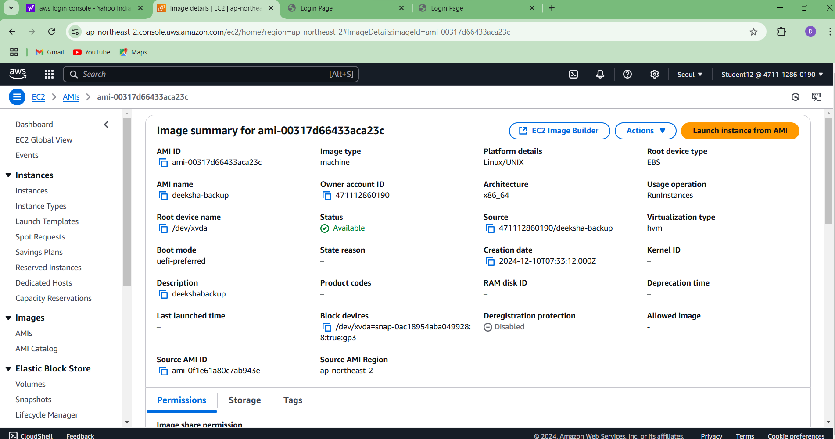

**After launching the backup server**

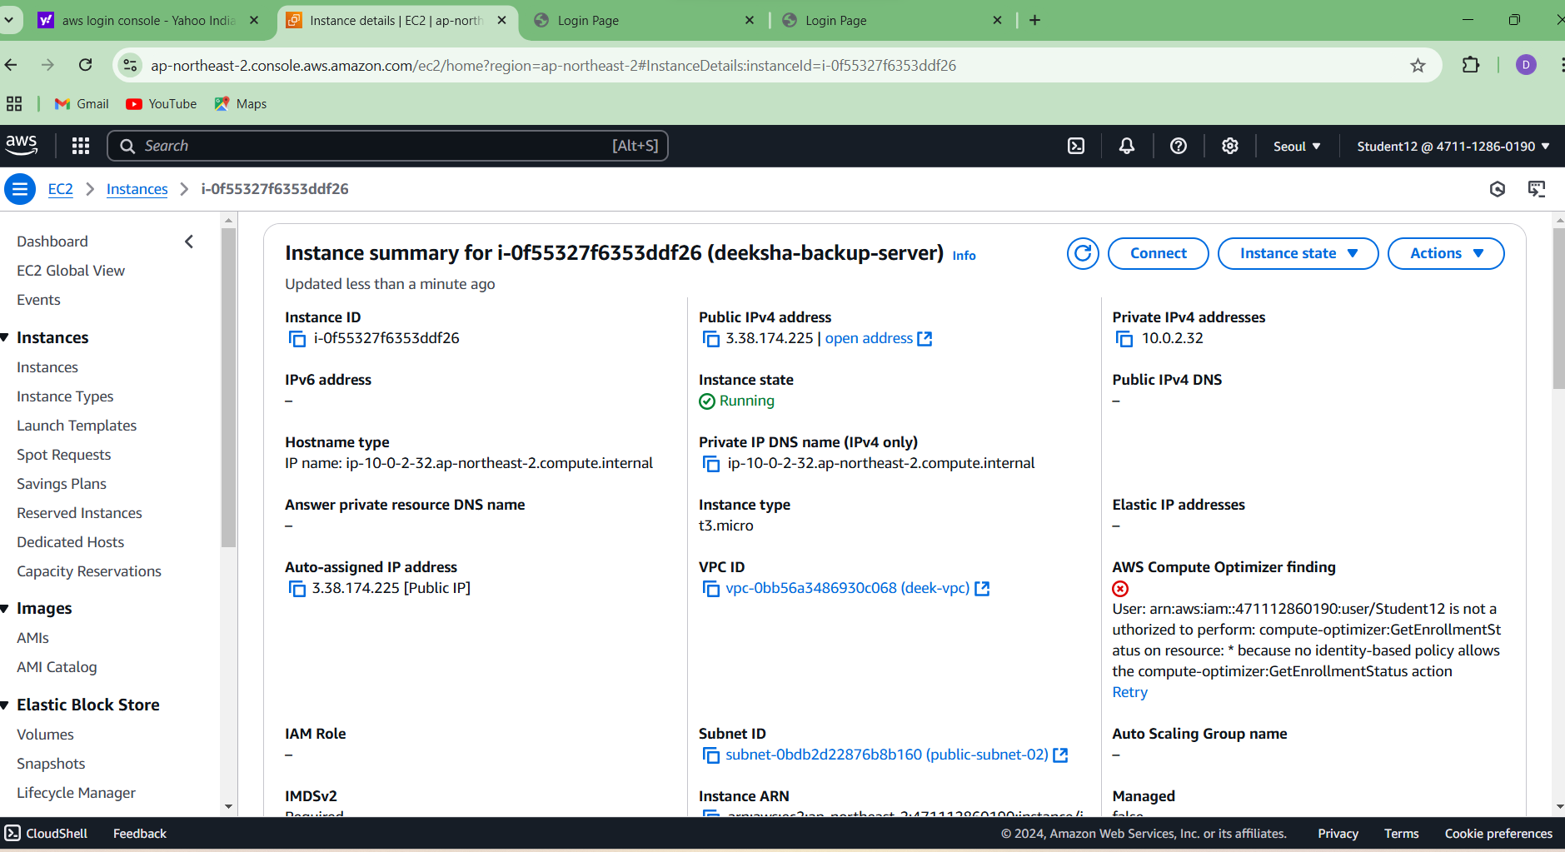

**Final result**

